The Spring City Race Track

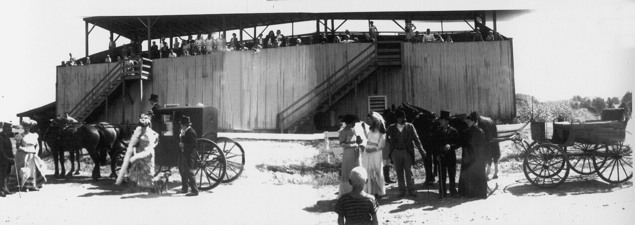
As early as February of 1892 there were numerous newspaper stories speculating about the possibility of a public driving park for Spring City. It became a reality when in September of 1892 a large plot of ground known as Schuylkill Heights was purchased from Samuel H. Egolf. That property bordered Wall Street and was located where the present day Spring City Elementary School sits. H. G. Ellis surveyed the plot and laid out the plans for a third of a mile horse racing course. There would be room in the center for a ball field and the track would also be available for bicycle races. The association also announced at this time that there would be no gambling allowed and no races scheduled on Sundays.

With the full support of local race fans the flat dirt oval track was completed just one month later in October. It wasn’t until the following summer of 1893 that the work on the poles and wire, the judge’s stand, and the grandstand were begun. In an overview map of Spring City that dates back to 1893 the race track can clearly be seen but no adjoining structures were shown.

It could be said that harness racing was one of the summer’s main attractions in the early 1900s in Spring City. Some of the early members of the Spring City Driver’s Association were Dr. Mewhinney, Edward Custer, J. F. Smale and Milton Latshaw. Milton Latshaw became treasurer of the association in 1896.

The next time you visit the Latshaw hardware store take a look up on the far wall near the front counter. Hanging there for all to see is a picture of Milton Latshaw and his prize winning pacer John Cook. The Latshaws generously allowed me to copy this picture of their grandfather for our newsletter. When we examined it closely we learned that it was taken in August of 1902 at the Spring City race track. The horse’s name was John Cook and he was described as a dark bay and a very fast pacer. Bert Latshaw recalled that one day out at the track after his grandfather had won a race, someone offered to buy John Cook for $1200.00. The swift reply was, “No! He is not for sale.” Bert recalls that a short time later this horse died.

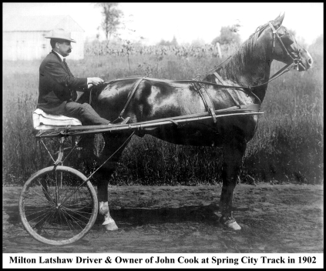
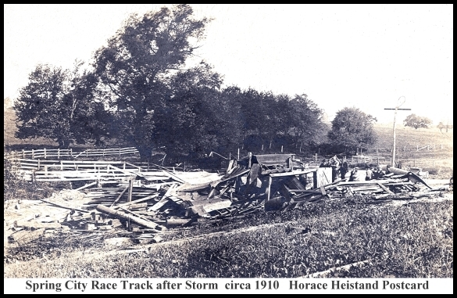
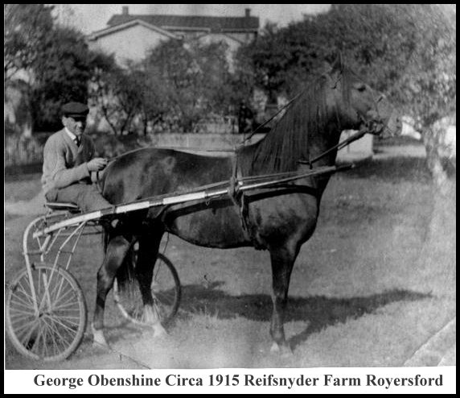
Over the years the association had its ups and downs but managed to continue until 1958. I was talking to Dick Obenshine whose father George used to race at the local track and he recalled going over to the track in 1958 and taking photos of the stables before they were torn down. He also recalled that for a short period of time in the thirties they tried automobile racing at the track. The track being flat didn’t really make an ideal place to race cars. Throw in the excessive dirt and loud noise from the stock cars and one can see why the venture was short-lived. Horse racing was always a part of the slate of activities but horse shows were also scheduled. The Memorial Horse Show was an annual event that started in 1943 and attracted large crowds of people.

I was talking to John Fischer about the race track and he told me of a very rare photo postcard he had purchased years ago. It was an early Horace Heistand published postcard view that dated back to 1905 -1910 era. He wasn’t completely sure what he had until Lawrence Shaner confirmed his suspicions. It was a photo of the Spring City race track grandstands after they had been destroyed by a storm. In the view one can see the boards strewn all about and several members of the Association surveying the damages. I want to thank John for sharing this photo-postcard with all of us.

When you first walk into the SFAHS barn museum one of the first photos to jump out at you is the large blowup of two sulky racers as they past the judges stand at the Spring City track.
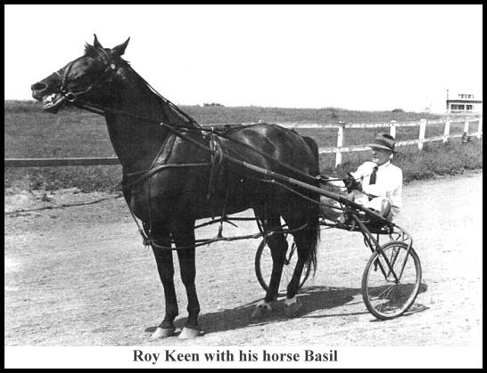
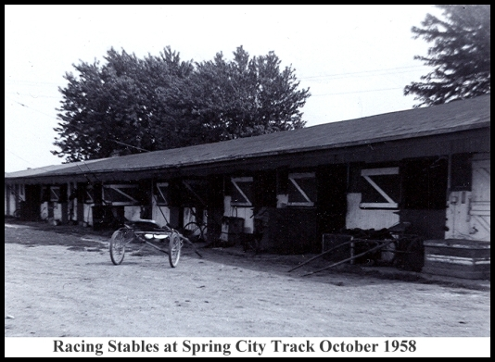
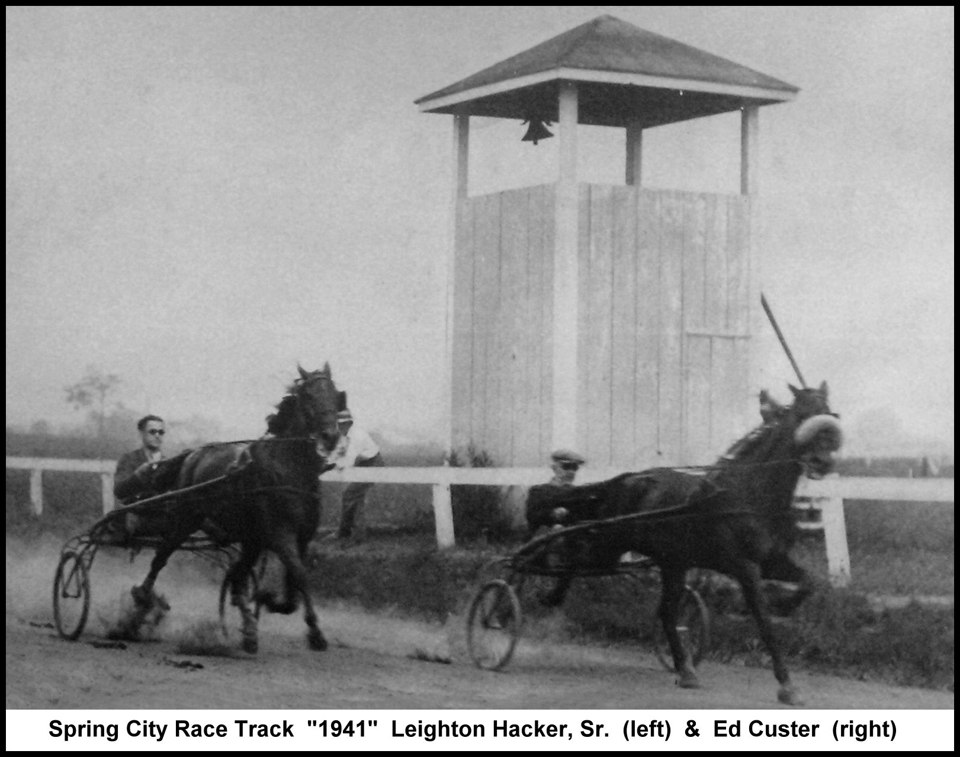
The two drivers in that 1941 photo are Leighton Hacker Sr. and Ed Custer. In fact the first question many people ask upon entering the museum is, “where was that track?” This question sparked my curiosity to learn more about the track and share it in the form of a newsletter.

I was talking to Leighton recently about his dad’s racing and what he remembered. Leighton remembers that in the early 30’s as a boy he used to sell race programs at the track. His father, Leighton Hacker Sr., who was a driver and involved with the association had race programs printed up at the Inter-Borough Press. His job was to walk through the grandstands before the race and sell the programs. He recalls that after WWII there seemed to be less racing events and more horse shows scheduled.

I talked with another one of our members, Pauline Hughes, whose father, Roy Keen, was a well known driver-owner. Roy hosted the annual association banquets held early on but they became so large they had to be moved to the Tall Cedars Temple. The annual banquets continued to grow in size and by 1930 there was a record crowd of 250 people in attendance. That evening the music was provided by a ten piece orchestra. There was an Amos & Andy minstrel show, several readings by Evelyn Deisher, and Don Urner of Royersford rounded out the evening’s entertainment with several accordion selections. Roast turkey was served to all. If you get the idea that racing in Spring City was a big thing you are correct.

In a post season race that was held in November of 1929 there were horses entered from four different states. Many of these horses had run in the Bellwood Hunt the previous week.  As the fifties came to a close so did the era of horse racing in Spring City. Pauline remembers there was some bitterness when the school board was looking for property to build the new Elementary School and selected the Wall Street location. Rumors of the race track being torn down were all over town. In an Inter-Borough Press Article dated March 28^{th,} 1957 it was stated that if plans materialized for the new Spring City Elementary School then this season may be the last for training trotters and pacers at the Spring City track. The stables were full at this time with many horses being housed and trained there. Among those owners who still had horses stabled there were: Henry Roediger, Roy Keen, Thomas Stauffer, Eddie Custer, Jonas Shoemaker, Leighton Guiden, Bill Allred, Clarence Grepps, Mr. Wall & Mr. Messig.  The new school opened in 1960.  What remains from the track today is but a few memories, a couple of old programs, some photos packed away in a box in someone’s attic, perhaps a trophy or racing uniform once worn by a jockey. Although this era came to an end almost 50 years ago I hope that in writing this story it will help answer a few questions, and if you are lucky, the next time you slow down to15 mph at the Wall Street school you may get a glimpse of the horses as they round that last turn.  W. C. Brunner | 